EX NO : 5 Classification using K-Nearest Neighbours
19.02.26 (KNN) and Decision Tree

SCENARIO 1: K-NEAREST NEIGHBOUR:
CONFUSION MATRIX:
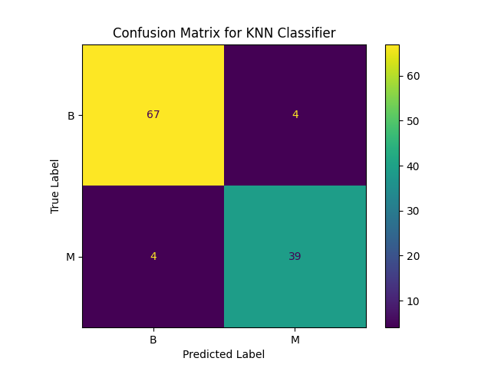

ACCURACY VS K VALUE:
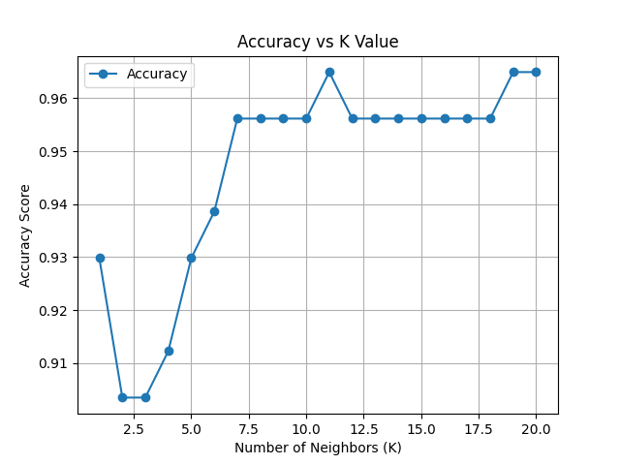

DECISION BOUNDARY:
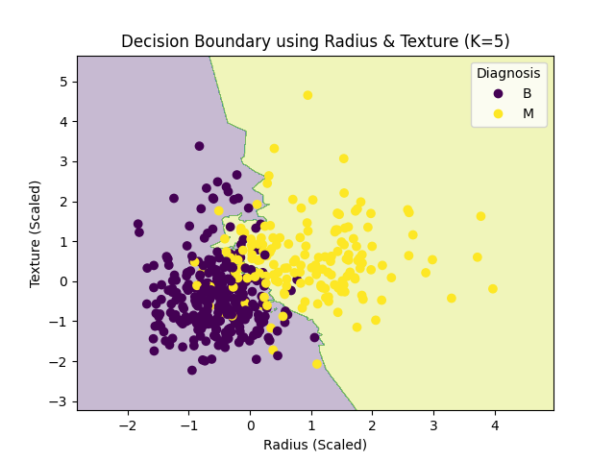
SCENARIO 2: DECISION TREE CLASSIFIER
Confusion Matrix:
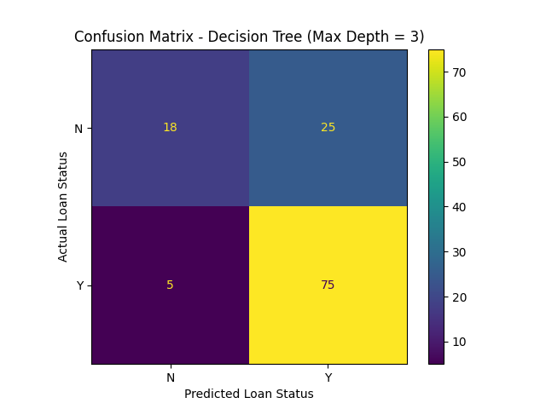

TREE STRUCTURE PLOT:

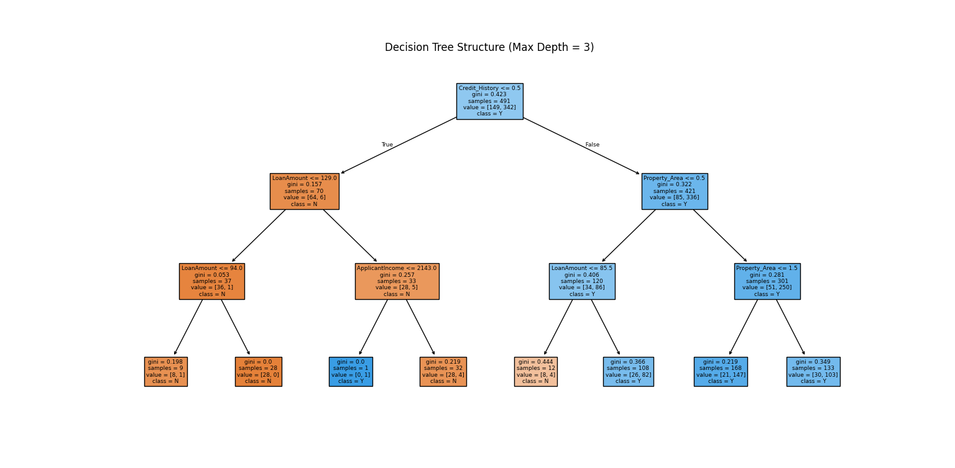

Feature Importance Plot:
